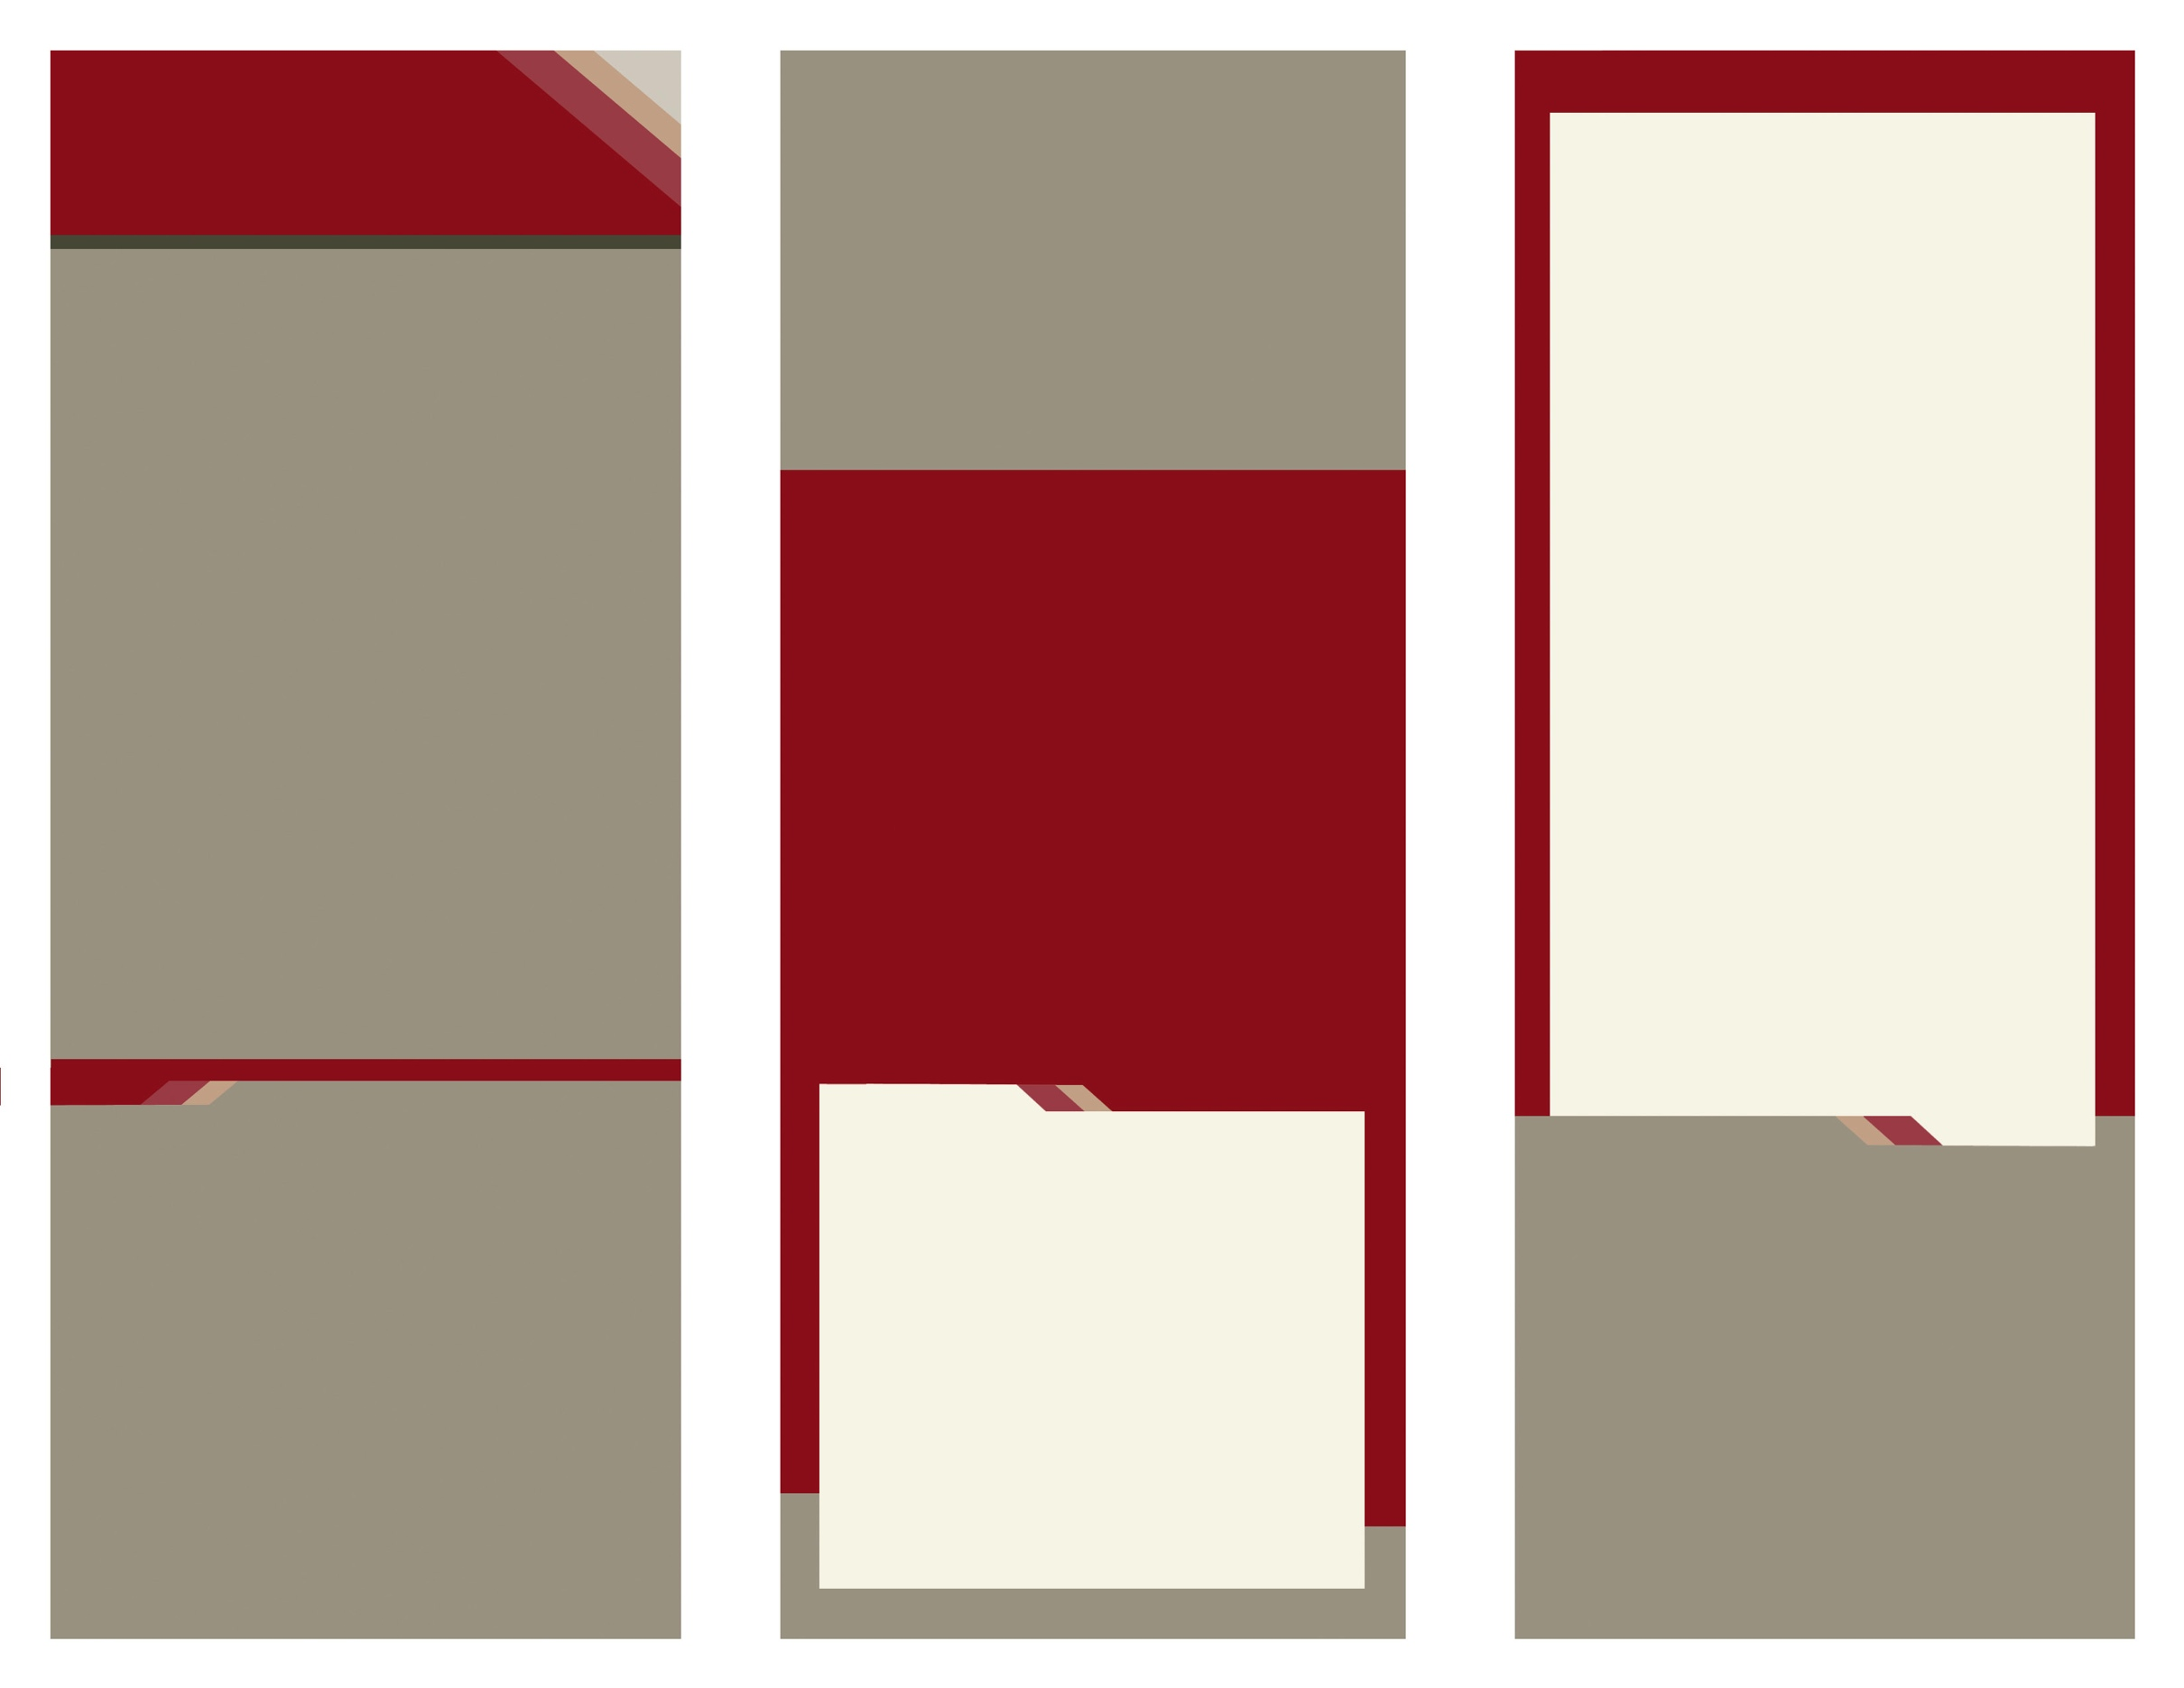

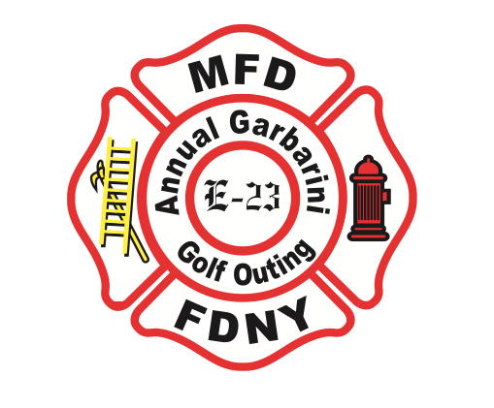

**PROCEEDS TO BENEFIT**

**MILLTOWN STUDENT SCHOLARSHIPS**

**MILLTOWN FIRE DEPARTMENT**

Delete text and place photo here.

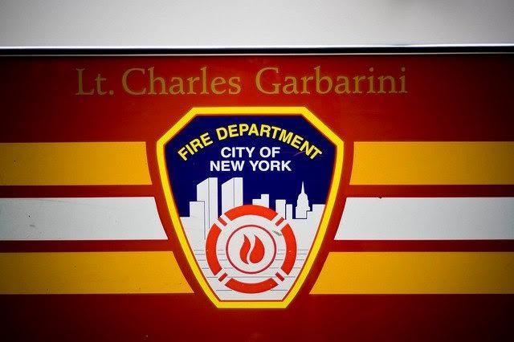

Delete text and place photo here.

**AWARDS**

**Lowest Team Score**

First, Second & Third

**Closest to the Pin**

Men & Women

**Longest Drive**

Men & Women

**Bob Balachick Memorial Award**

**“The Shortest Drive”**

In Memory of MFD Firefighter who has answered his last alarm

**“BEAT THE HUNKY”**

**Beat Jules Dekovics, and receive an extra ticket for a chance to win free entry into the 2022 event**

19th Annual

Charles Garbarini Golf Outing

**Sponsored by the Milltown Fire Dept.**

Enter Contact Information Here | 1127 Lombard Blvd. San Francisco, CA 59802 | phone 555.555.5555 | fax 555.555.5555

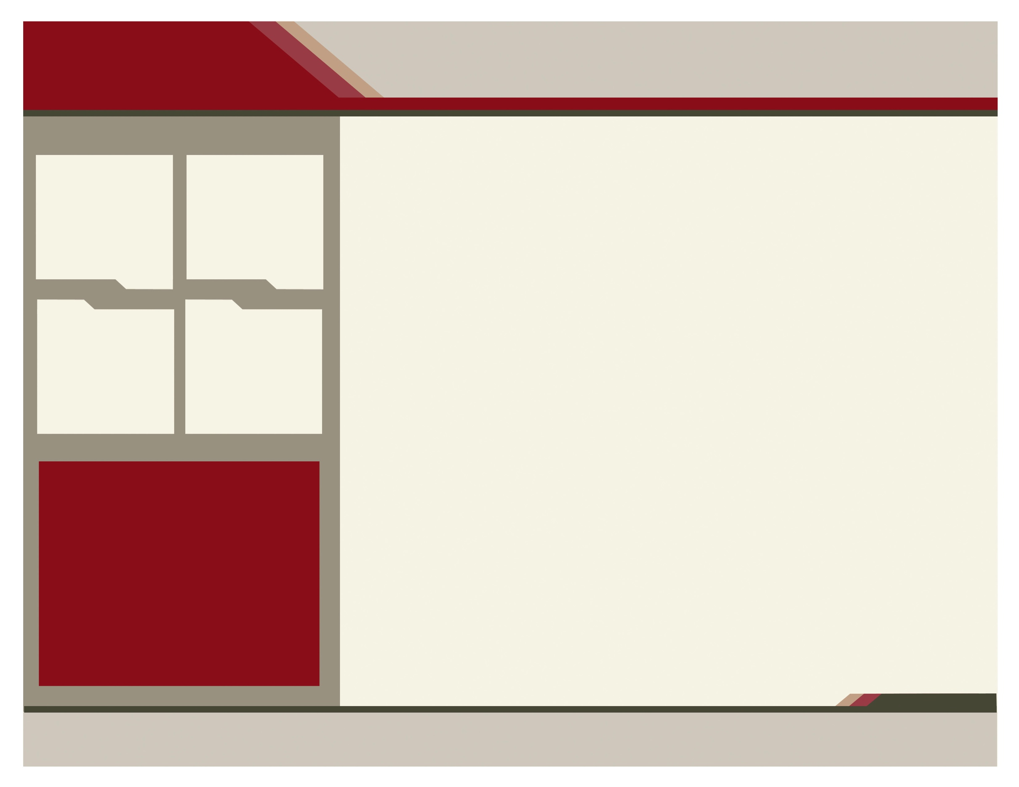

**Milltown Fire Department Inc.**

**8 Royal Court**

**Milltown, NJ 08850**

**Phone | 908-227-7153**

**E-Mail: mfdgolfouting@gmail.com**

**“we remember and will always remember”**

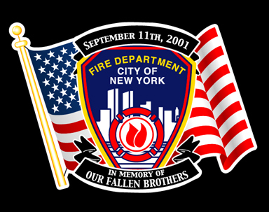

**June 21, 2021**

**cranbury golf club**

**49 southfield Rd.**

**west windsor, new jersey**



**schedule**

**REGISTRATION DEADLINE JUNE 14, 2021**

8 AM – REGISTRATION & BREAKFAST

10 AM – SHOTGUN START

3:30 PM – DINNER & AWARDS

(AS SOON AS GOLF CONCLUDES)

$135 PER GOLFER

**CAPTAIN: ________________________**

**PLAYER 2: _______________________**

**PLAYER 3: _______________________**

**PLAYER 4: _______________________**

**EMAIL ADDRESS:**

**_________________________________**

**PHONE #: ________________________**

**ADDRESS: ________________________**

**_________________________________**

**CONFIRMATION SENT OUT UPON RECEIPT**

**FIRST COME FIRST SERVED – 144 SPOTS**

**PROPER GOLF ATTIRE REQUIRED NO JEANS, NO CUT-OFFS ALLOWED**

**SHORTS ALLOWED**

**PLEASE RESPECT THE COURSE RULES**

**MAKE CHECKS PAYABLE TO:**

**Milltown Fire Department Inc.**

**8 Royal Court**

**MILLTOWN, NEW JERSEY 08850**

**PLAYER REGISTRATION FORM**

**PLATINUM SPONSOR $1000.00**

* COCKTAIL HOUR SPONSOR
* FOURSOME INCLUDED
* HOLE SPONSOR SIGN

**GOLD SPONSOR $750.00**

* BEVERAGE CART SPONSOR
* TWO GOLFERS INCLUDED
* HOLE SPONSOR SIGN

**SILVER SPONSOR $500.00**

* BREAKFAST SPONSOR
* ONE GOLFER INCLUDED
* HOLE SPONSOR SIGN

**BRONZE DELUXE SPONSOR $250.00**

* BREAKFAST SPONSOR
* HOLE SPONSOR SIGN

**BRONZE SPONSOR $100.00**

* HOLE SPONSOR SIGN

**SPONSORSHIP LEVEL**

**SPONSORSHIP**

It has been 19 years since that horrific day in September of 2001 and our resolve still remains. We have made life long friends and we celebrate the lives of our lost brothers that day especially our extended family in the Garbarini family and our brothers from FDNY. We treasure them as well as all the supporters of this event over the past 19 years. We thank you all and truly appreciate your support.

19th Annual charles garbarini golf outing

sponsored by the milltown fire department

2008

2006

2009

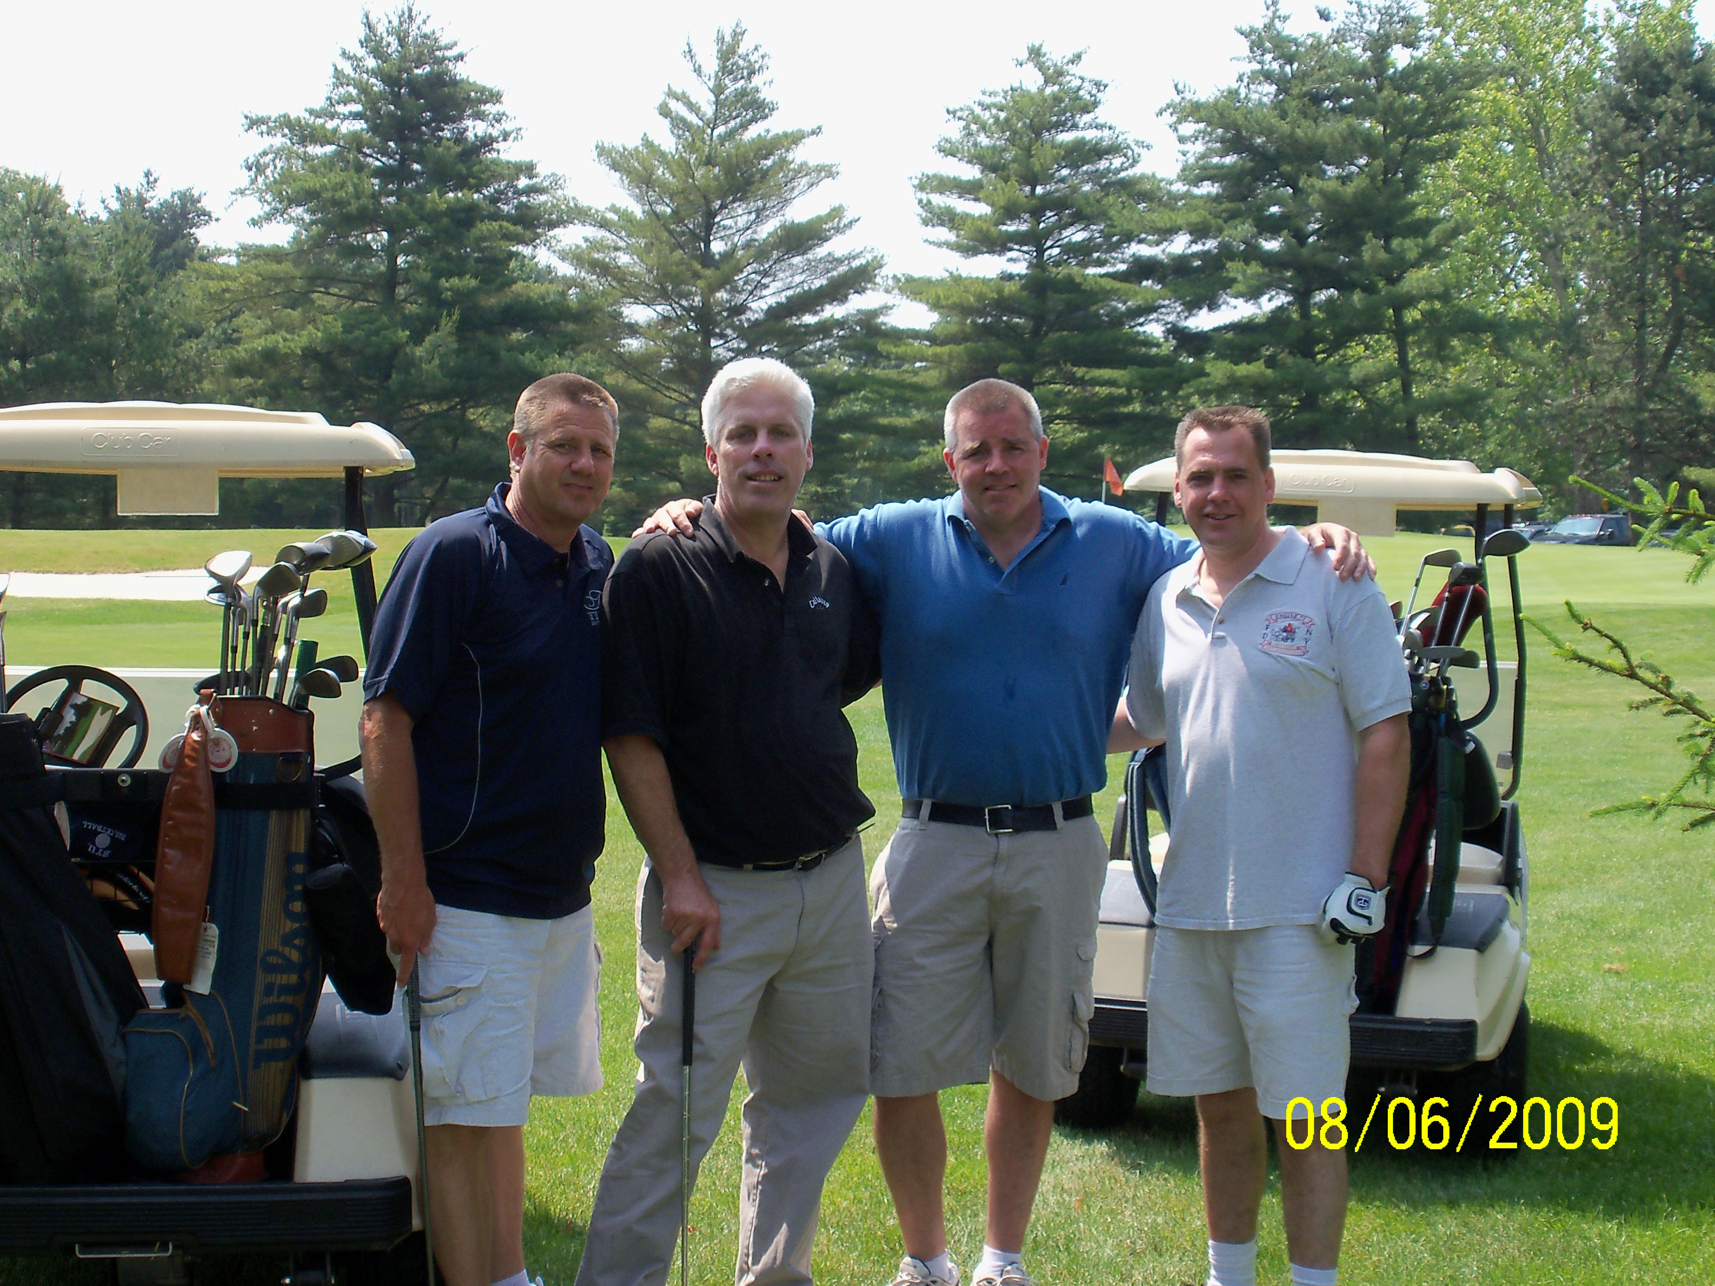

Delete text and place picture here.

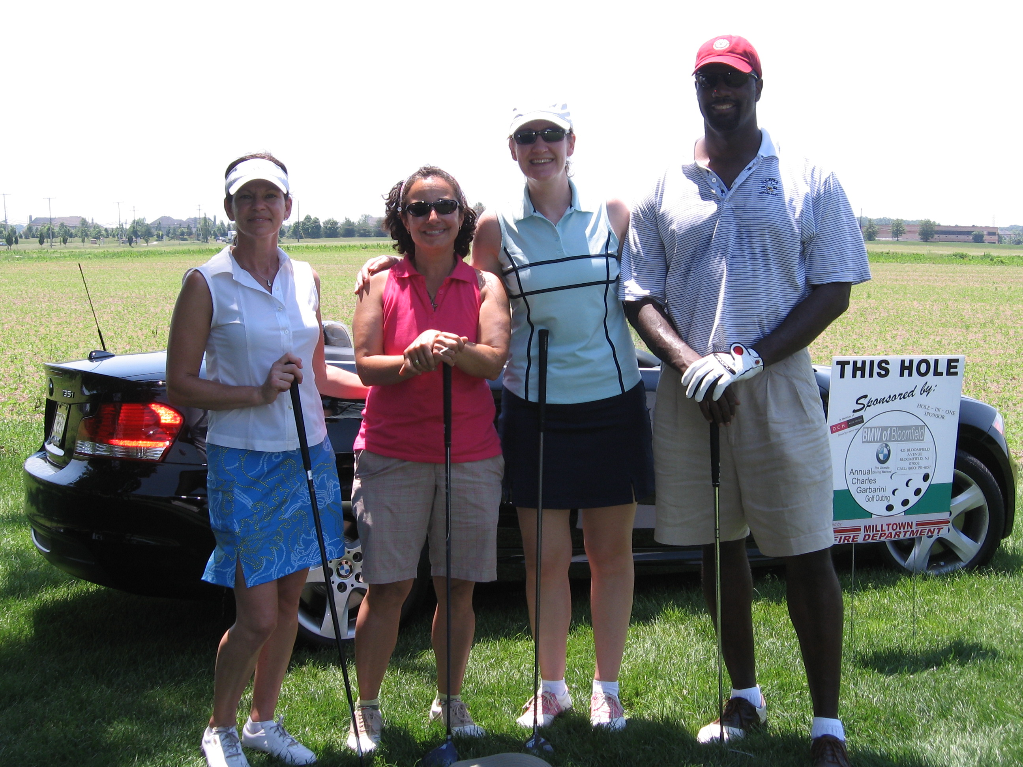

Delete text and place picture here.

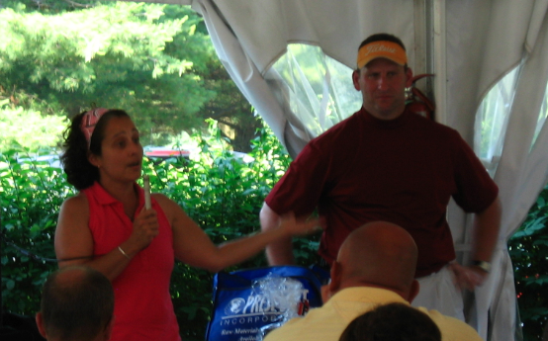

Delete text and place picture here.

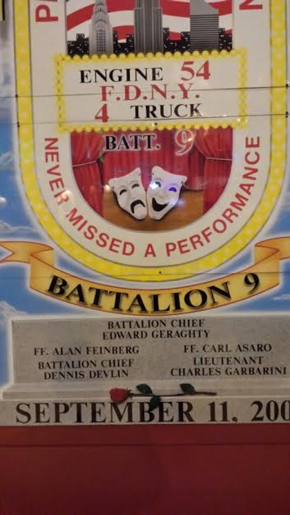

Delete text and place picture here.