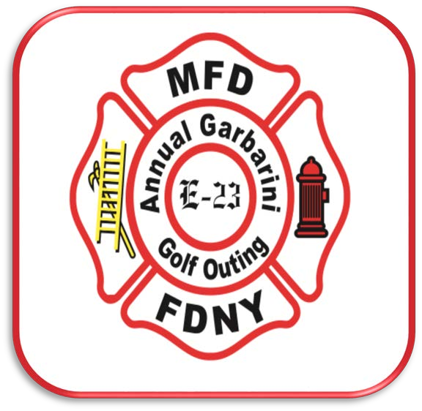
!
MONDAY

JUNE 21st

19TH ANNUAL CHARLES GARBARINI GOLF OUTING
SPONSORED BY THE MILLTOWN FIRE DEPARTMENT
ANNUAL EVENT IN MEMORY OF LT. CHARLES GARBARINI MURDERED THAT HORRIFIC DAY IN SEPTEMBER 2001.
PROCEEDS WILL BENEFIT
- SCHOLARSHIPS FOR TWO MILLTOWN STUDENTS
(ONE IN SPECIAL MEMORY OF NICOLE SURACE)
- MILLTOWN FIRE DEPARTMENT
THE DAY INCLUDES GOLF, FOOD AND BEVERAGES, PRIZES AND GIVEAWAYS.
CRANBURY GOLF CLUB – WEST WINDSOR, NEW JERSEY
$135 PER GOLFER
FOR FURTHER INFO CONTACT BOB: 908-227-7153
COVID 19 UPDATE

New Jersey Executive Order #153 Issued by Governor Phil Murphy

Per Cranbury Golf-Club
“We appreciate the opportunity to give our sponsors and attendees an outlet to get fresh air and exercise in a safe environment, while also contributing to a great cause. We pride ourselves in working with Cranbury Golf-Club to provide somewhere for our guests to enjoy the game of golf, and we have included some very important changes to ensure everyone's safety outlined below. “
- Two person riding carts return to normal but we will offer the single occupancy golf cart option. Cart availability may be limited depending on rider demand.
- Starting Monday, June 15th the Golf Shop and restrooms access will be limited and guest must wear a mask when entering the building.
- Further details regarding the lifting of restrictions on flag sticks, bunker rakes, and ball washers will be released at a later time.
As a reminder, we are still sanitizing all our high-touch surfaces to keep everyone safe during these unprecedented times.
General Guidelines
Self-screening:
Players are expected to comply with the course COVID-19 policies. In addition, players are expected to self-screen prior to attending the event and it is the responsibility of the player to comply with NJ State travel guidelines, which are as follows:
Unvaccinated travelers and residents returning from any U.S. state or territory beyond the immediate region (New York, Connecticut, Pennsylvania, and Delaware) should self-quarantine at their home, hotel, or other temporary lodging following recommendations from the CDC:
- If travel is unavoidable, travelers should consider getting tested with a viral test (not an antibody test) 1-3 days before the trip and again 3-5 days after the trip.
- If travelers test positive, they should self-isolate for at least 10 days and should postpone travel during that time.
- If travelers test negative, they should quarantine for a full 7 days after travel.
- If testing is not available (or if the results are delayed), travelers should quarantine for 10 days after travel.
Players are also expected to ask themselves the following questions, and withdraw if the answer to any of these is “yes”.
Within the last fourteen (14) days, have you:
- Been diagnosed with COVID-19?
- Been in close contact with anyone who has been diagnosed with COVID-19?
- Been advised to quarantine by a doctor or other medical authority?
- Experienced symptoms consistent with COVID-19, such as:
  - Fever over 100.4° Fahrenheit?
  - Experienced shortness of breath?
  - Experienced abnormal coughing symptoms?
  - Experienced loss of taste or smell, chills, shaking, sore throat or muscle aches?
  - Experienced any other unusual flu-like symptoms?
If you answered yes to any of the above, the Milltown Fire Department expects you to withdraw from the event. In order to withdraw, please email mfdgolfouting@gmail.com or call the Bob Sannwaldt at 908-227-7153
Standard Player Health:
- If you have a fever, cough or other symptoms of COVID-19, please stay home. Any player displaying symptoms will be required to go home.
- Avoid touching your mouth, nose, and eyes.
- Do not touch any equipment that is not yours.
- Wash your hands frequently. If you are unable to wash your hands, use hand sanitizer.
Face Coverings
In accordance with the New Jersey Executive Order issued on July 8, 2020, the New Jersey State Golf Association now requires the wearing of face coverings in various locations and situations during the event.
Withdrawals:
- The Milltown Fire Department will offer a refund for anyone who WDs if they are sick or uncomfortable participating for safety/health reasons.
- The Milltown Fire Department asks players to WD with as much advance notice as possible to allow us to fill the vacated spot from our waiting list. If at all possible, please do not wait until the day of the event to WD.
- The following refund deadlines will apply:
  - Refund policies: Before above deadline date - Full refund. After above deadline but before a player’s starting time – refund minus a $50 surcharge. No-shows (with no notice) receive no refund.

